Lab 1: Getting Started with Redpanda Serverless

Table of Contents
Table of Contents 2
Introduction 3
Learning Objectives 3
Prerequisites 4
Verify Your Environment 4
Part 1 — Creating Your First Serverless Cluster 5
Step 1 — Log in to Redpanda Cloud 5
Step 2 — Create the Cluster 5
Step 3 — Create a User 7
Step 4 — Explore the Cloud Console 9
Part 2 — Connecting with rpk Cloud Login 12
Step 1 — Find the Connection Instructions 12
Step 2 — Log in via CLI 12
Part 3 — Your First Topic and Message 14
Step 1 — Create a Topic 14
Step 2 — Produce a Message 14
Step 3 — Consume from the Topic 14
Part 4 — Inspecting Data in the Cloud UI 16
Step 1 — Navigate to Topics 16
Step 2 — View Your Message 17
Part 5 — Inspecting Cluster Metadata 18
Step 1 — Check Cluster Health 18
Step 2 — Describe Broker Metadata 18
How This Compares to Local or Traditional Kafka 19
Knowledge Check 20
Troubleshooting 20
Next Steps 20
Conclusion 21

Introduction
In traditional Kafka environments, starting a cluster often requires provisioning virtual machines, managing ZooKeeper or KRaft controllers, configuring files, and orchestrating containers.
Redpanda Serverless takes a fundamentally different approach. It provides a fully managed, instantly available streaming data platform that scales automatically. You don't manage any brokers, nodes, or infrastructure, you just connect and start streaming.
In this lab, you will create your first Redpanda Serverless cluster in Redpanda Cloud.
You will explore:
- How Redpanda Serverless abstracts infrastructure complexity.
- How to navigate the Redpanda Cloud Console.
- How to configure credentials and connect securely.
- How to use the rpk CLI to interact with a remote, serverless cluster.
This lab builds your operational intuition before you begin producing and consuming data in later modules.

Learning Objectives
Upon completing this lab, you will be able to:
- Explain the benefits of a Serverless streaming architecture compared to self-hosted deployments.
- Provision a Redpanda Serverless cluster in Redpanda Cloud.
- Generate securely authenticated credentials (SASL/SCRAM).
- Configure the rpk CLI to connect to a remote cloud cluster.
- Inspect remote cluster metadata and connection endpoints.

Prerequisites
To complete this lab, you will need:
- Redpanda Cloud Account: A free trial or existing account at cloud.redpanda.com.
- Internet Browser: To access the Cloud UI.
- Redpanda rpk installed: Locally or inside your VM.
- Internet Access: Your terminal must be able to reach cloud endpoints (port 9092).

Verify Your Environment
Run these commands inside your terminal to ensure the CLI is ready:
rpk version

Confirms rpk is installed on your machine.
python3 --version

(Not required yet, but needed for future data-production labs.)

Part 1 — Creating Your First Serverless Cluster

Step 1 — Log in to Redpanda Cloud
- Open your browser and navigate to cloud.redpanda.com.
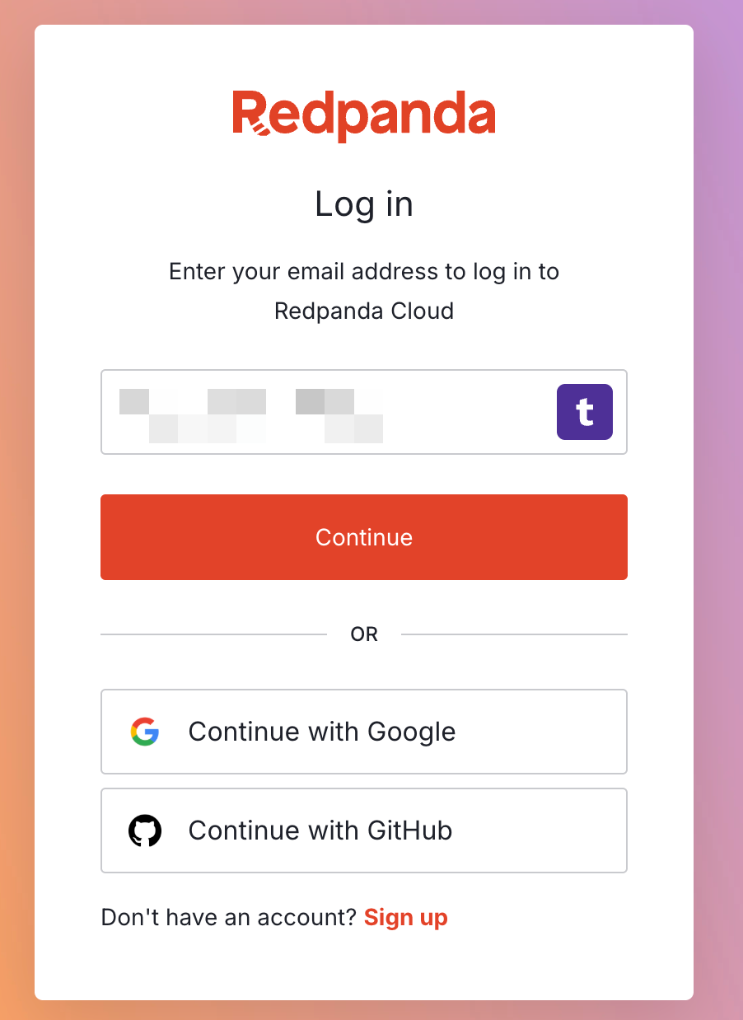
- Log in with your credentials.

Step 2 — Create the Cluster
- On the Home screen, click Create cluster.
- Select Serverless.
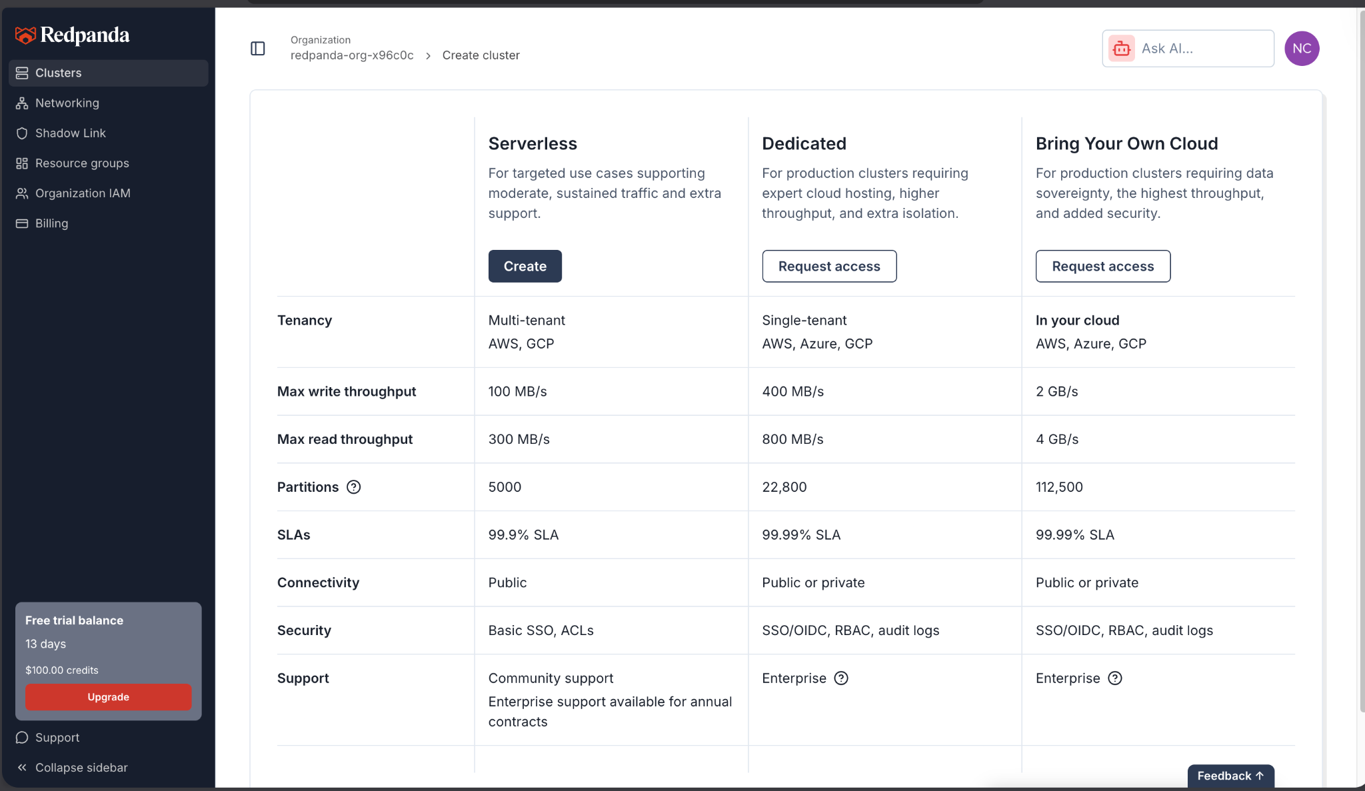
- Provide a Cluster name (e.g., lab-serverless-cluster).
- Choose a Region closest to your physical location to minimize latency.
- Click Create.
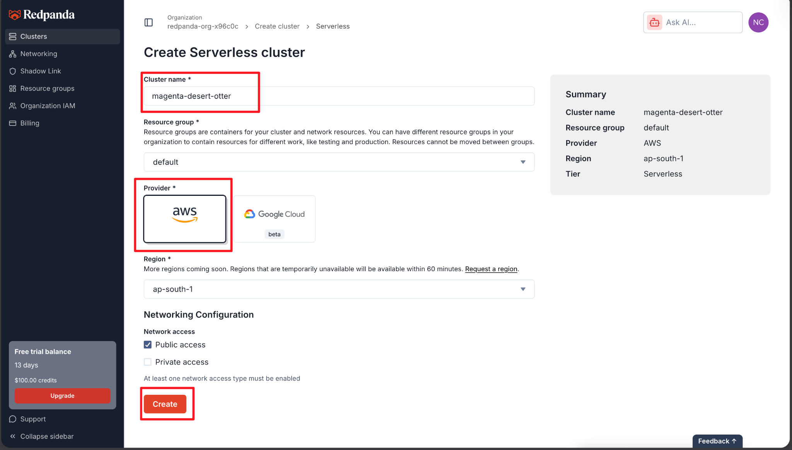
Note: Your cluster provisions in seconds. Unlike dedicated infrastructure, there are no VMs to boot or networks to peer manually.

Step 3 — Create a User
Because Serverless clusters are exposed over the public internet, they are secured by default using SASL/SCRAM authentication and TLS encryption.
- Once the cluster is ready, Click on the cluster
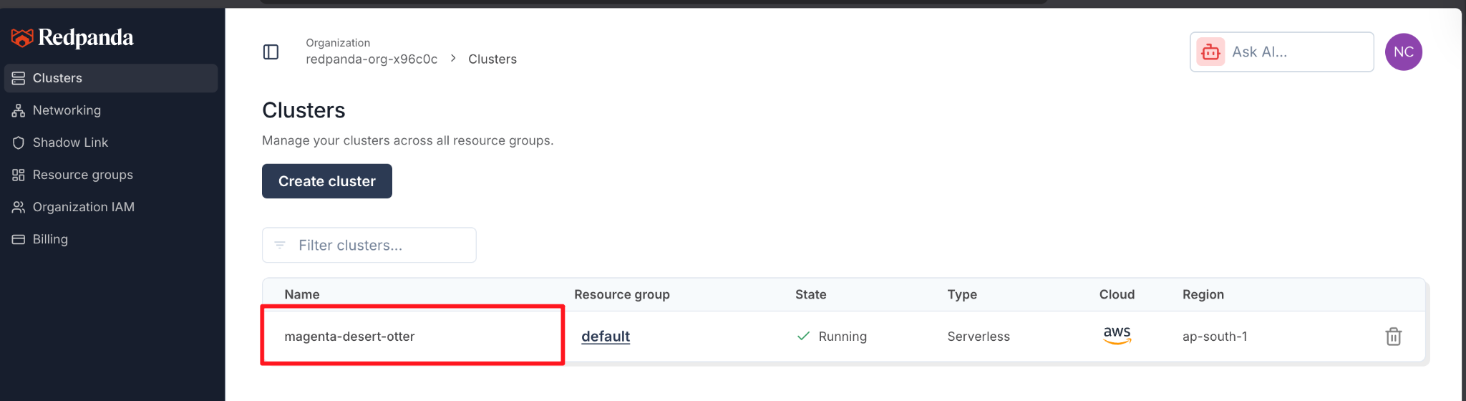
- Go to Security -> Users in the left-hand navigation.
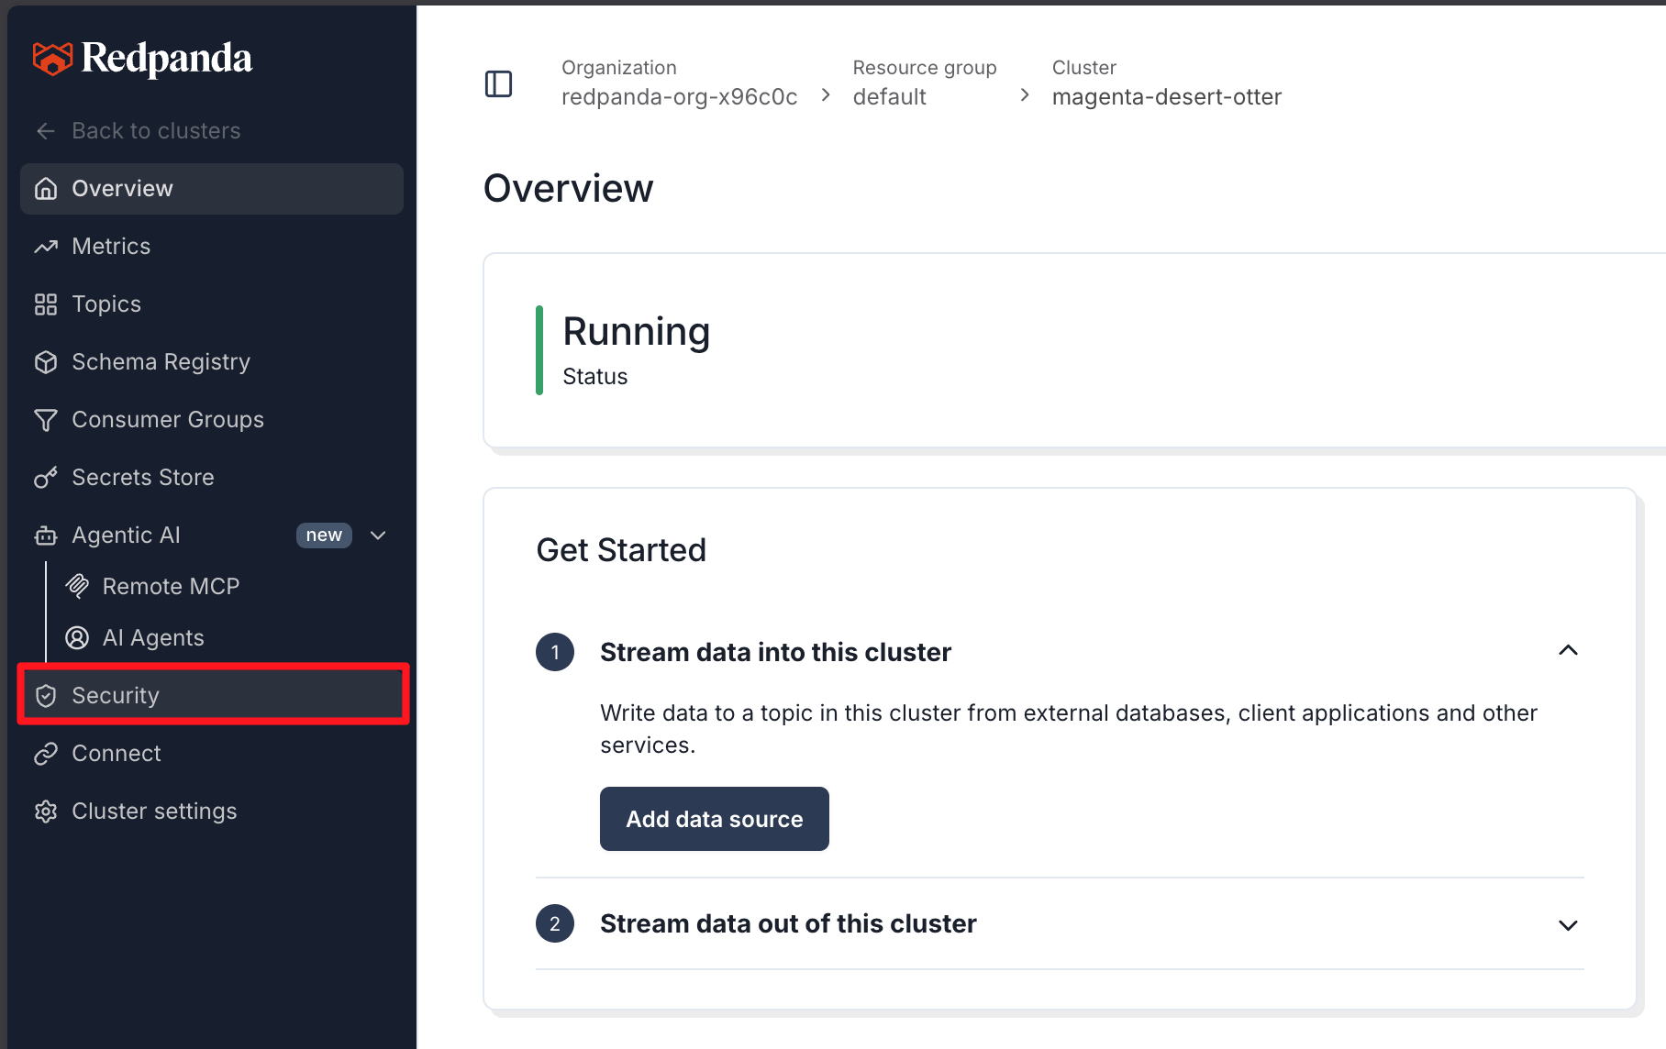
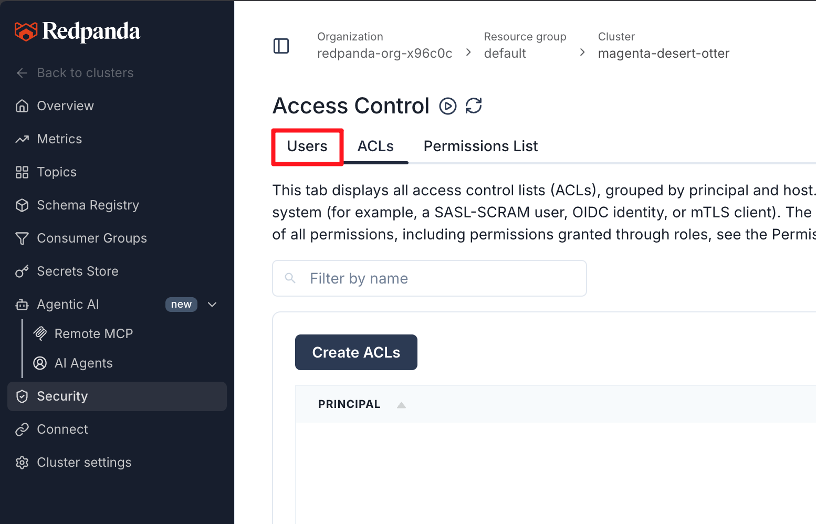
- Click Create user.
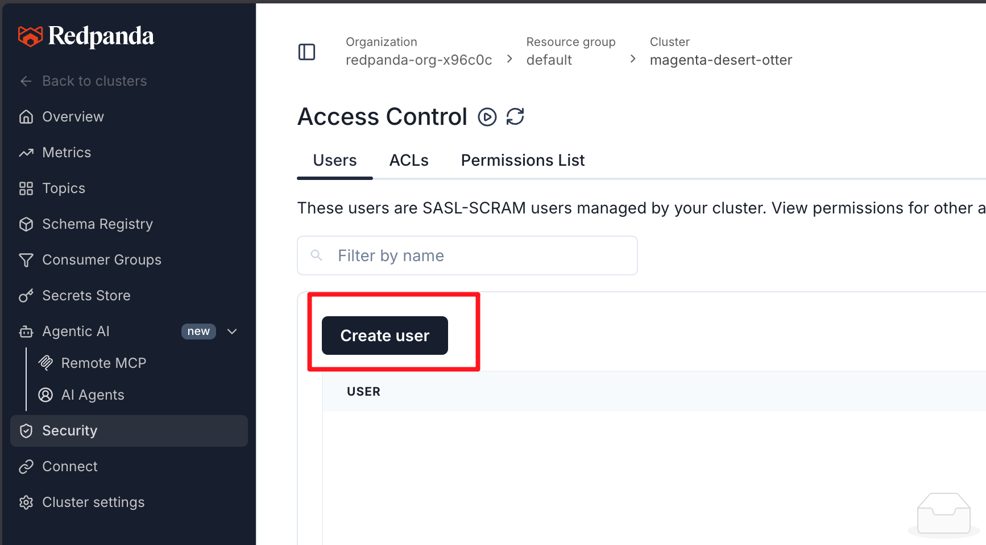
- Enter a username (e.g., lab-user) and a password.
- Select the SCRAM-SHA-256 mechanism.
- Click Create.
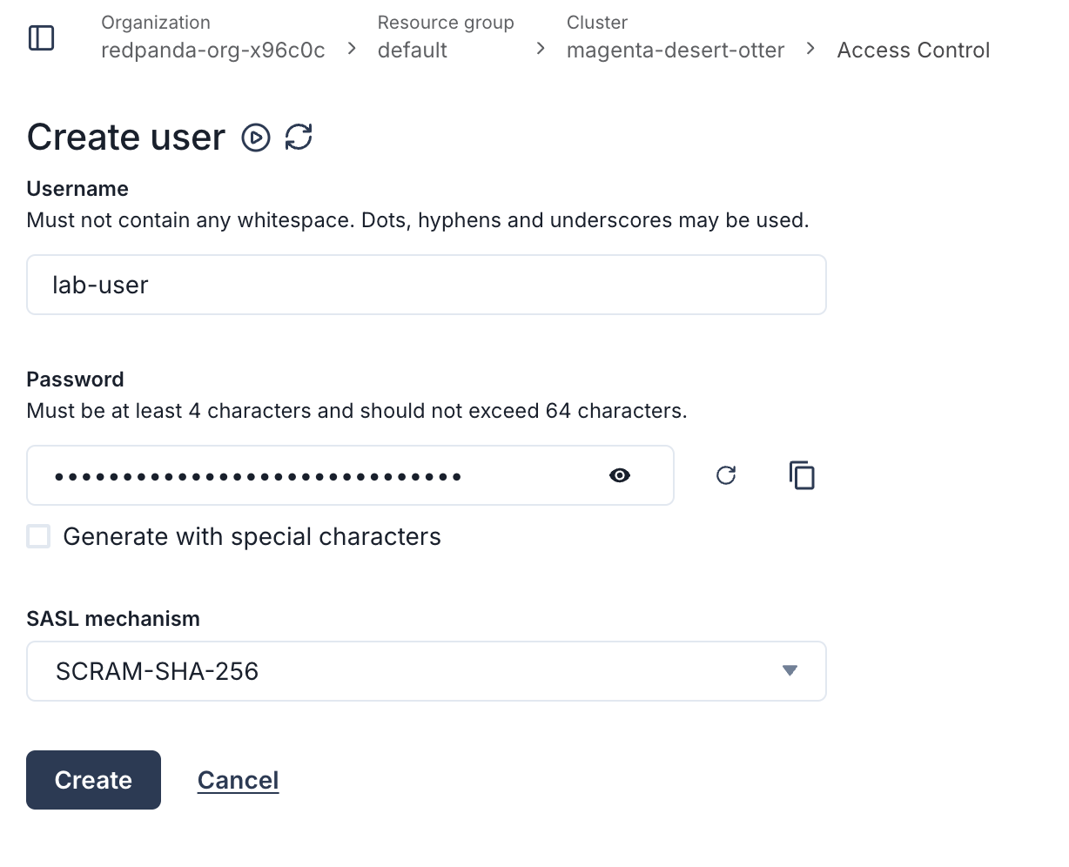
(Save this password in a safe place! You will need it in the next step.)

Step 4 — Explore the Cloud Console
Take a moment to look around the Redpanda Cloud UI. It replaces the local Redpanda Console container.
- Overview: Displays connection instructions, including tabs for CLI, Kafka API, and Schema Registry.
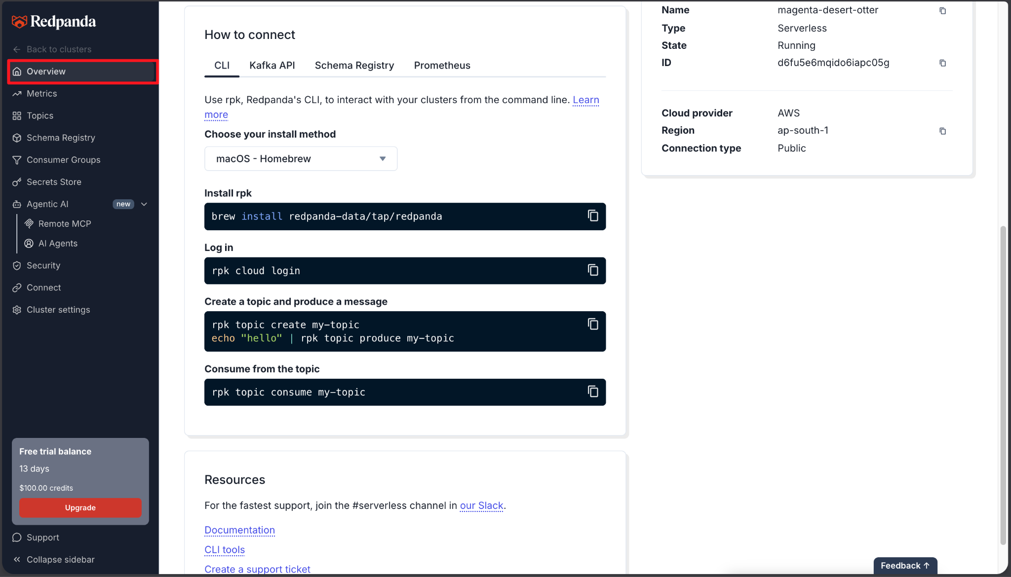
- Topics: Where you will manage your data streams.
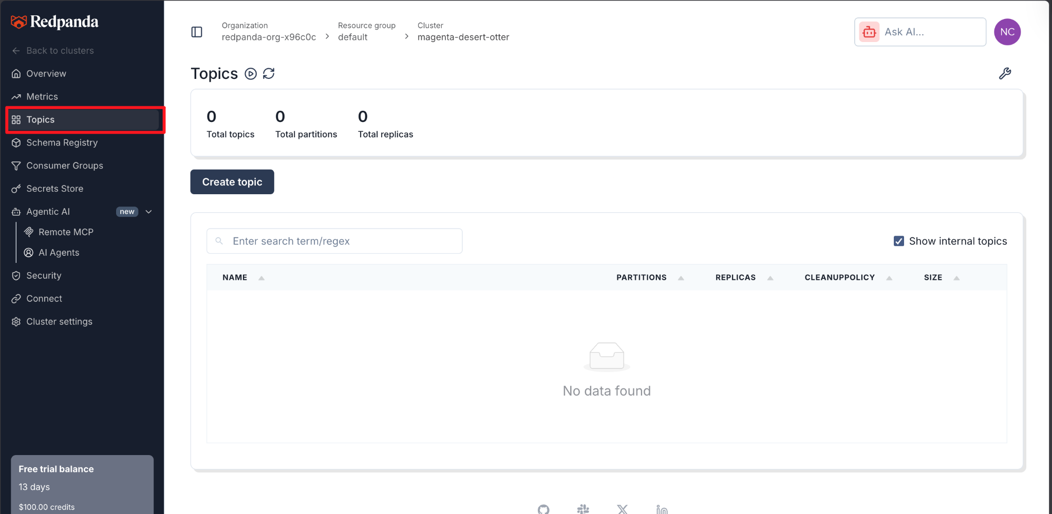
- Consumer Groups: Where you can monitor active readers.
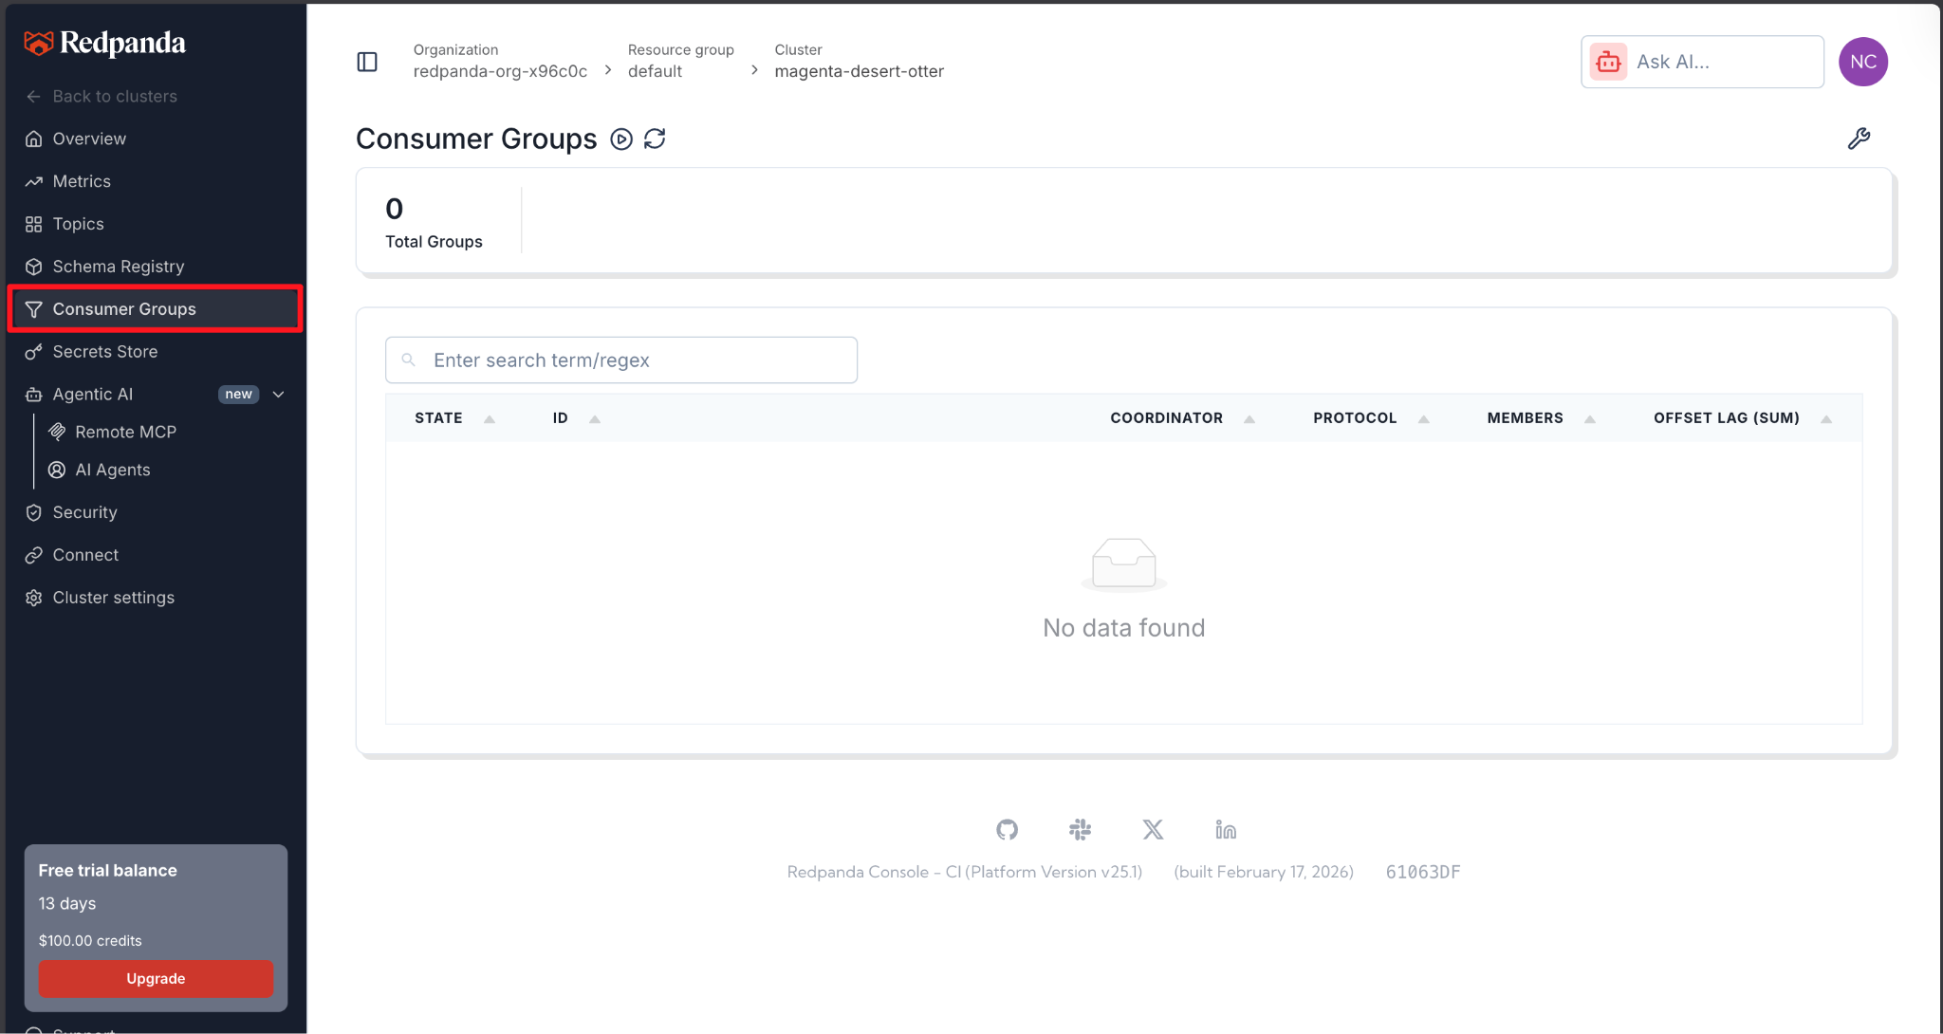

Part 2 — Connecting with rpk Cloud Login
To interact with your new Serverless cluster from your terminal, the easiest method is to use Redpanda's cloud authentication, which automatically configures your local rpk profile.

Step 1 — Find the Connection Instructions
- In the Redpanda Cloud UI, click Overview in the left sidebar.
- Locate the How to connect section and ensure the CLI tab is selected.
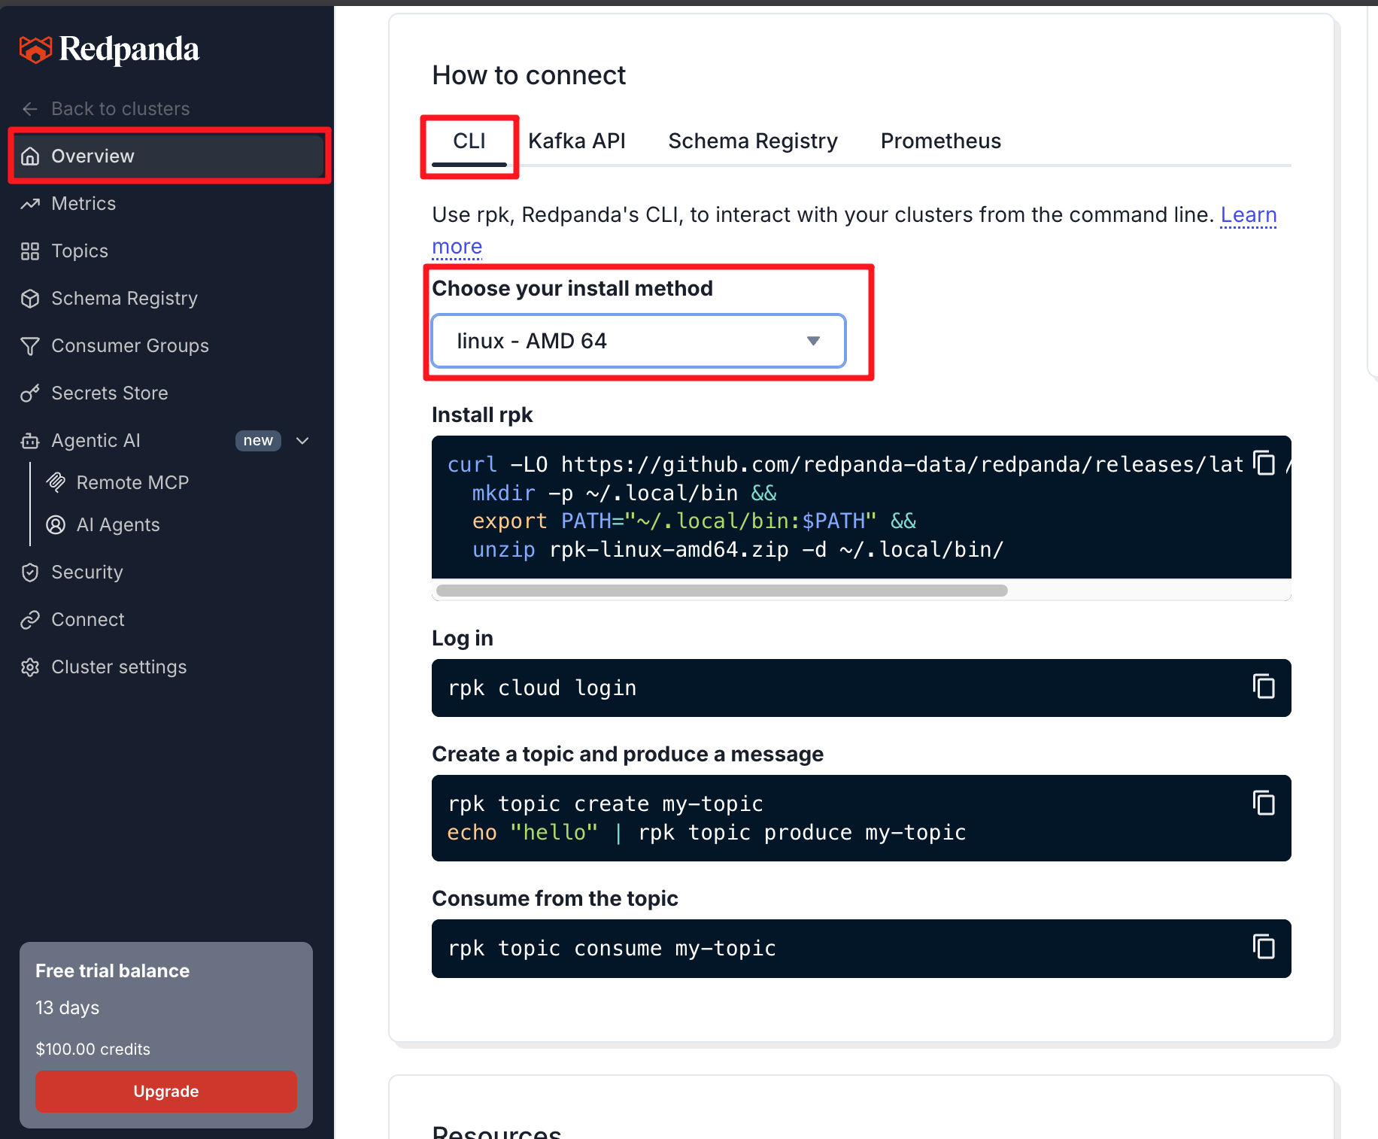

Step 2 — Log in via CLI
Run the following command in your terminal:
rpk cloud login

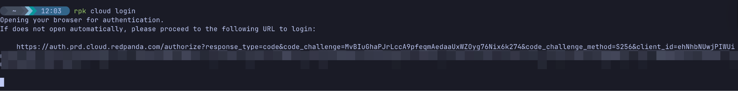
This will open a browser window prompting you to authorize the CLI. Once authorized, rpk securely retrieves your cluster details and automatically creates a connection profile for your serverless environment.
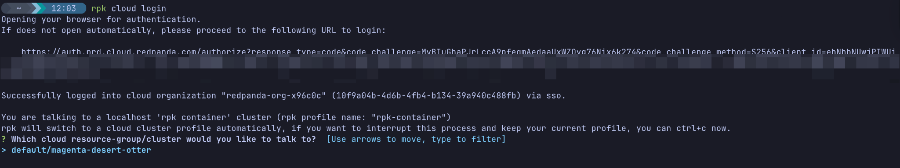
(Note: For programmatic application access later, you will use the Kafka API tab to create specific SASL/SCRAM credentials, but for administrative CLI tasks, rpk cloud login is all you need.)
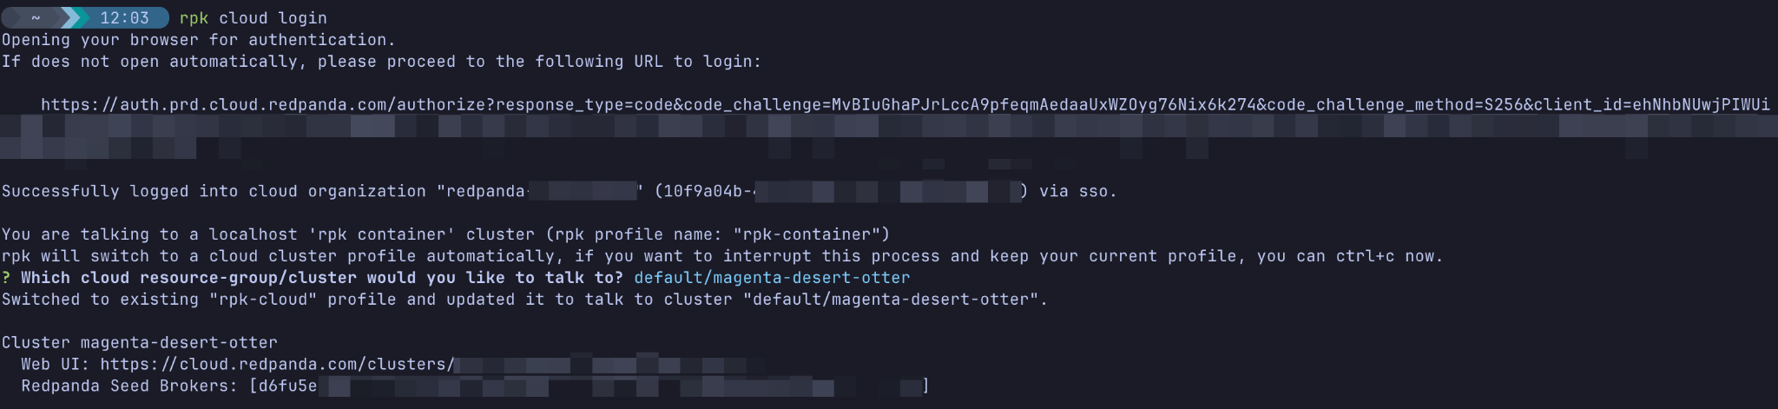

Part 3 — Your First Topic and Message
Now that you are connected, let's verify the cluster works by following the quickstart commands provided in the UI.

Step 1 — Create a Topic
Run:
rpk topic create my-topic
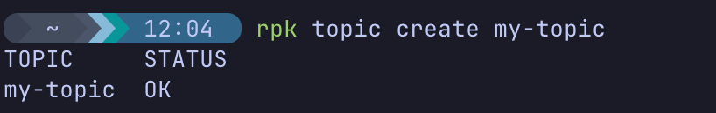

Step 2 — Produce a Message
Pipe the text "hello" directly into your new topic:
echo "hello" | rpk topic produce my-topic

Step 3 — Consume from the Topic
Read the message back:
rpk topic consume my-topic
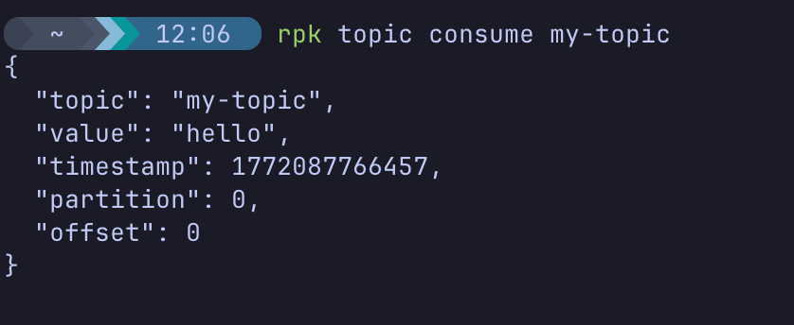
You should see your "hello" message appear in the terminal along with its metadata (partition, offset, etc.). Press Ctrl+C to exit the consumer.

Part 4 — Inspecting Data in the Cloud UI
Now that you've produced and consumed data via the CLI, let's verify it visually in the Redpanda Cloud interface.

Step 1 — Navigate to Topics
- In the Redpanda Cloud UI, look at the left-hand navigation menu.
- Click on Topics.
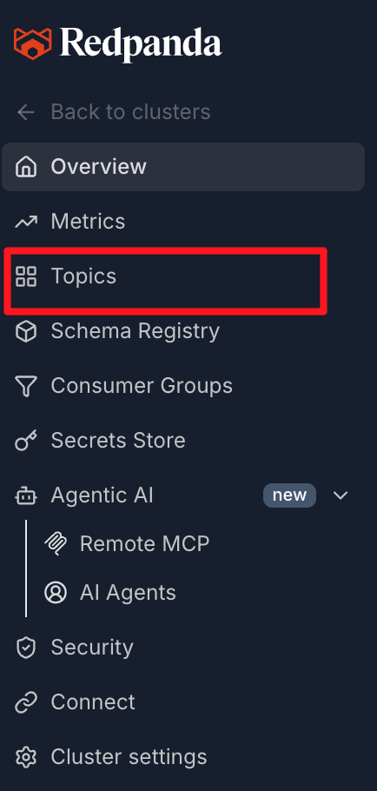
- You should see my-topic listed here. The UI automatically reflects changes made from the CLI.
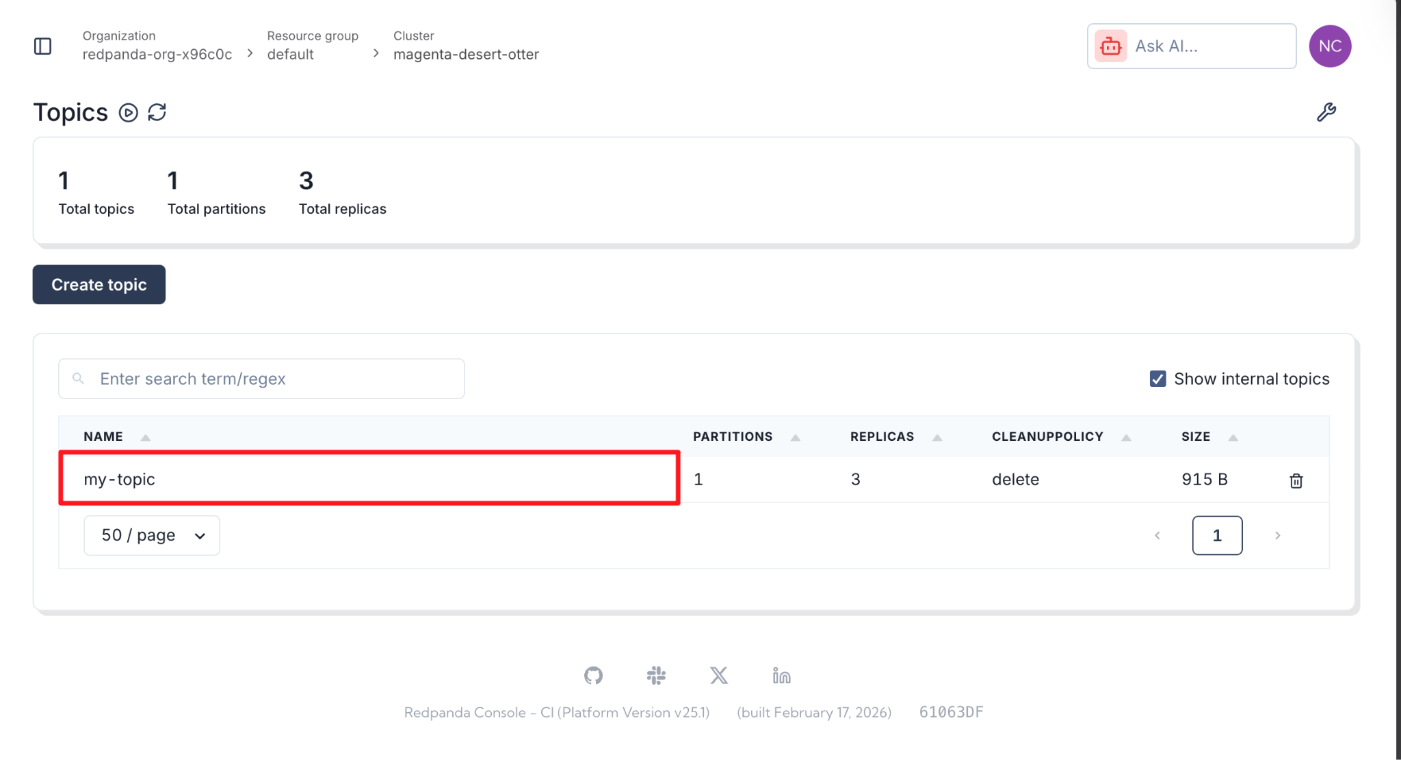

Step 2 — View Your Message
- Click on my-topic to open its details.
- Navigate to the Messages tab.
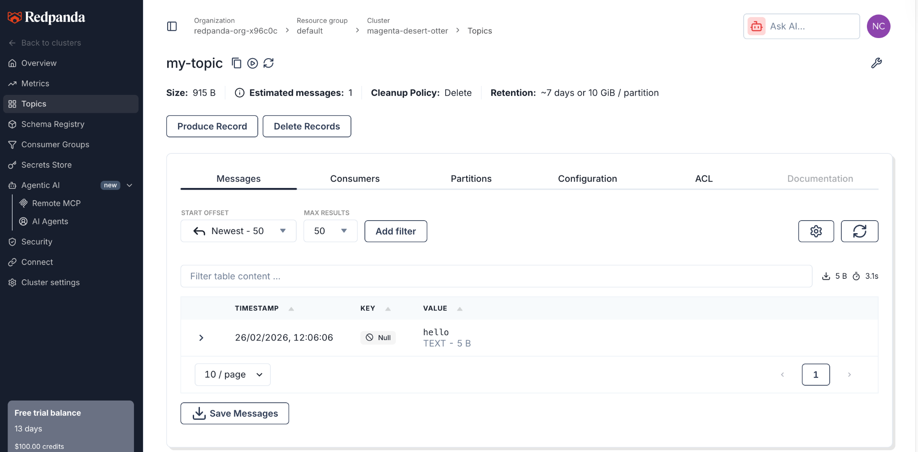
- You will see the "hello" message you produced earlier, along with its timestamp, partition, and offset.

Part 5 — Inspecting Cluster Metadata

Step 1 — Check Cluster Health
Run:
rpk cluster health

Expected Output Includes: Confirmation that the cluster is reachable and healthy. Because this is Serverless, Redpanda handles the underlying node health, controller status, and partition balancing automatically.

Step 2 — Describe Broker Metadata
Run:
rpk cluster metadata

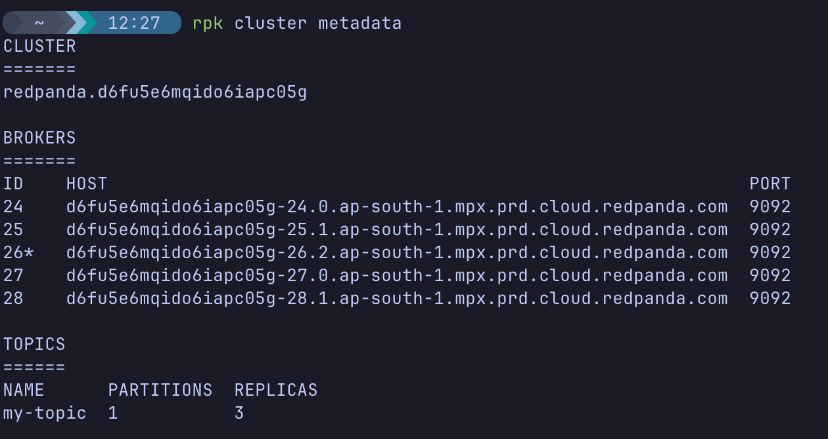
Observe:
- You will see an array of broker IDs (e.g., 0, 1, 2) that Redpanda Cloud is managing for you behind the scenes.
- The addresses resolve to Redpanda's public cloud endpoints rather than local IP addresses.

How This Compares to Local or Traditional Kafka
- Traditional: Install Java, configure ZooKeeper/KRaft, configure server.properties, start services, configure local networking.
- Local Docker: Run rpk container start, manage Docker networks and container lifecycles.
- Serverless: Click "Create", run rpk cloud login, and immediately start producing messages. Redpanda handles the sizing, scaling, and infrastructure.

Knowledge Check
- Which rpk command automatically authenticates your CLI with Redpanda Cloud and configures your connection?
- Where in the Redpanda Cloud UI can you find quick-start commands for the CLI, Kafka API, and Schema Registry?
- True or False: In a Serverless cluster, you must manually restart brokers if a node goes down.
- How do you stop the rpk topic consume command from listening for new messages?

Troubleshooting
Symptom: rpk cloud login fails to open a browser.
- Cause: You might be running the CLI in a headless VM environment without a GUI.
- Solution: The CLI will typically provide an alternate URL in the terminal. Copy and paste that URL into your local machine's browser to complete the authentication flow.
Symptom: rpk cluster info hangs or times out.
- Cause: Often caused by corporate firewalls blocking outbound traffic on port 9092.
- Solution: Check if you are on a VPN. Try connecting from a different network.
Symptom: rpk command not found
- Cause: rpk is not installed or not in your system's PATH.
- Solution: Follow the "Install rpk" instructions shown in the Overview -> CLI tab of your Redpanda Cloud UI.

Next Steps
Since Serverless clusters charge based on usage (and scale to zero when inactive), you can safely leave this cluster running for future labs without incurring massive compute costs like traditional provisioned clusters.
If you prefer to keep a completely clean environment, you can delete the cluster:
- Go to the Redpanda Cloud UI.
- Navigate to Cluster Settings -> Delete Cluster.

Conclusion
In this lab, you successfully created a Redpanda Serverless cluster and connected to it securely.
You learned that:
- Serverless removes the need to manage containers, VMs, or complex configurations.
- rpk cloud login provides a frictionless way to authenticate and manage remote cloud environments.
- Producing and consuming messages can be done in seconds without worrying about underlying infrastructure.
- The Redpanda Cloud UI provides powerful visual insights and straightforward connection instructions.
You now have a production-ready, infinitely scalable streaming platform ready for data.

